MASSIMO LUCIDI
My name is Massimo Lucidi and I am a CAT 3 road racer and have been racing since I was 10 years old. My main strengths are climbing and endurance road racing. In Southern California we have very few road races and I am excited to participate in the Belgian races that I have heard so much about.
I am eager to learn more skills and European racing specifically in much larger fields composed of very good junior racers. Also, we have very good weather here so racing in the rain will be interesting to further develop my racing skills.

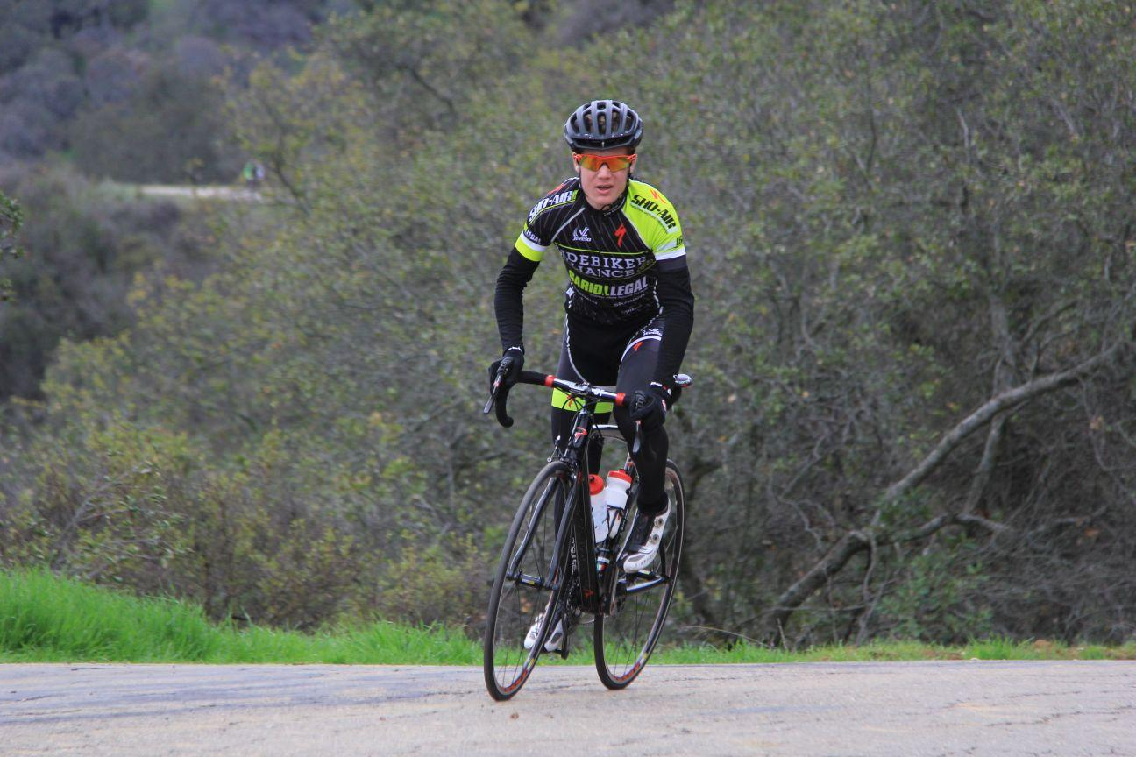

KENJI YOSHIMOTO
My best cycling accomplishments are 1st Red trolley, 4th SDSR road race, 2nd jurupa valley. My goals for Europe is to podium/ win a kermesse and to finish with the top riders at Sint-Martinusprijs
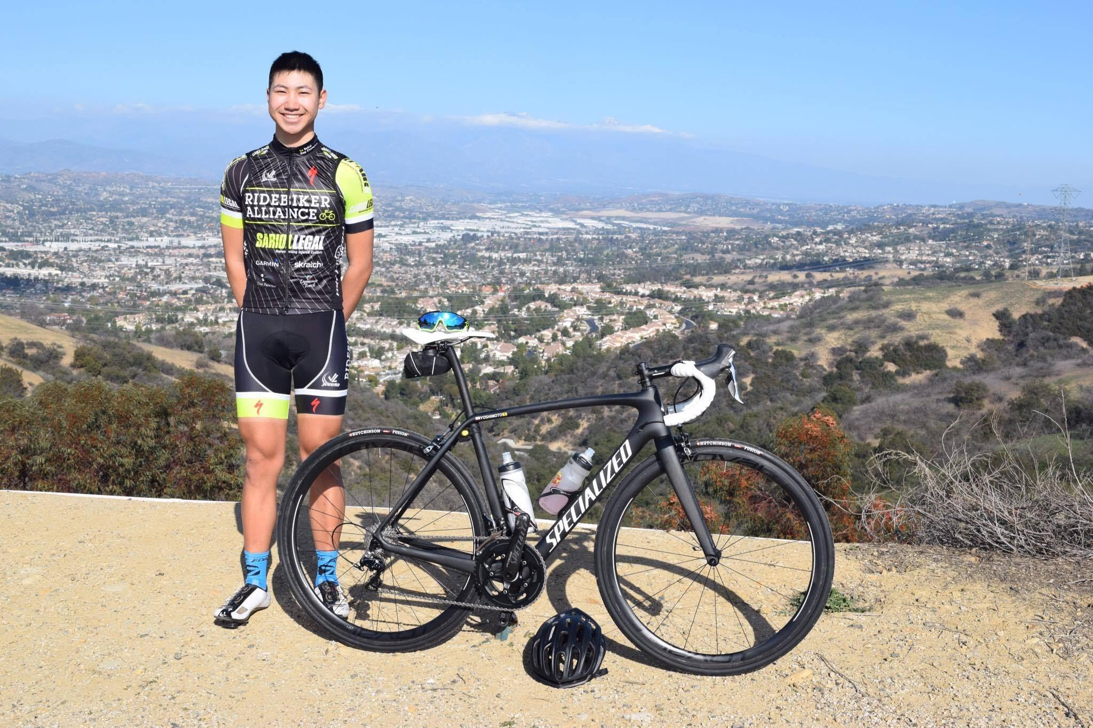
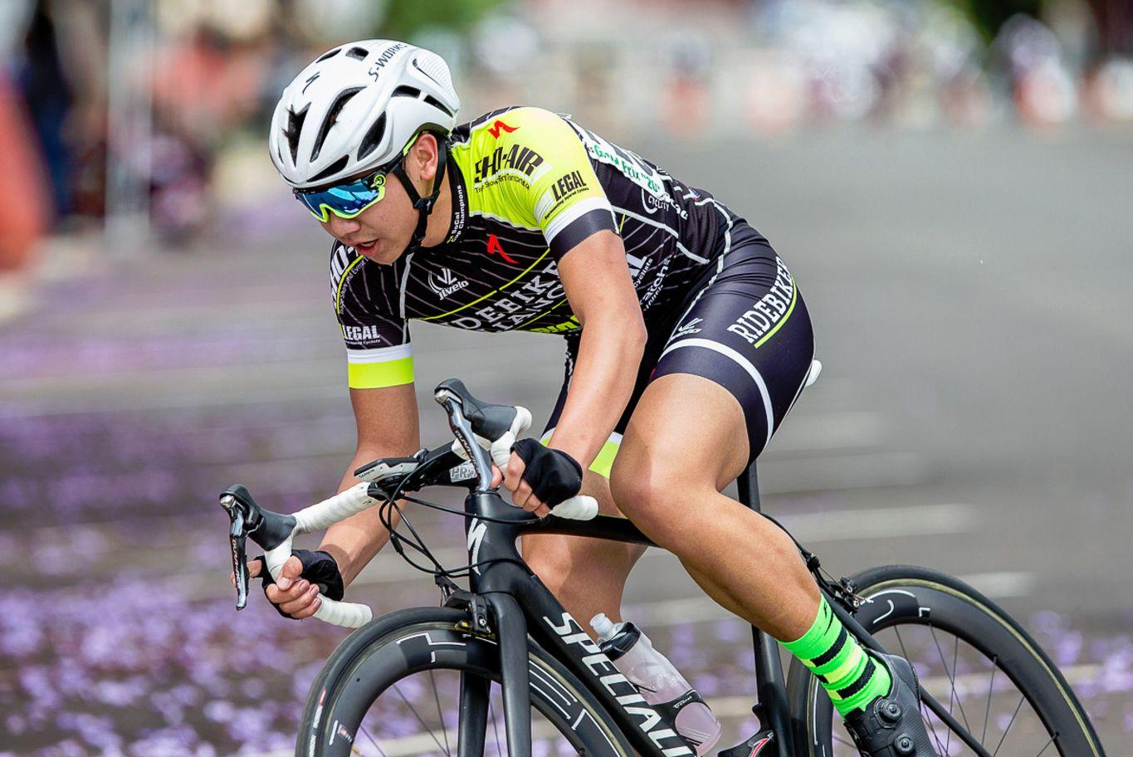

ADRIAN MUNIZ
My Name is Adrian Muniz and I am 16 years old. I'm academically competitive and physically competitive. I love to race Track Bikes and Road Bikes while I've placed 5th in the scratch and points at Junior US nationals, while on the Road I've competed in local pro races and won multiple Junior races in my category. While also managing my time to live a well balanced life socially, academically, and physically by pursuing my passion of racing bikes. In all honesty I love to suffer on my bike. We all suffer, keep going.

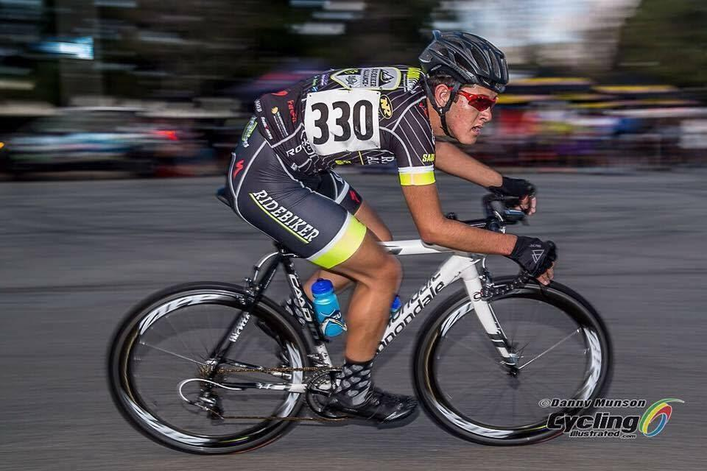

DAVID HERRERA
I am David Herrera and I'm from Colombia. I came to the U.S.A when I was 9 and was really passionate about doing cycling since my family was doing it. I wanted to follow the right steps and become a professional bike racer and travel the world to race. It’s been a long journey since I started. I am enjoying every second of this sport because it's a way that I can express who I really am. I'm super excited to race kermesse and the UCI 2.1 stage race Sint-Martinusprijs. I’m looking forward to get a top 5 for the GC and enjoy racing. My best results so far are getting top 5 for Road Race and Criterium at Valley of Sun stage race in Arizona; also 4th place at Sea Otter Classic Road Race in California.
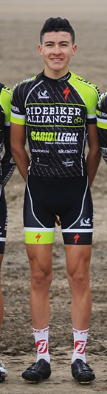

CESAR REYES
My name is Cesar Reyes and I am 17 years old. I have been doing cycling for almost two years. My goals in Europe are to get a new experience on their way of racing and learn a lot of new thing on and off the bike. My goal for the Sint-Martinusprijs stage race is to give it my all and win a stage!
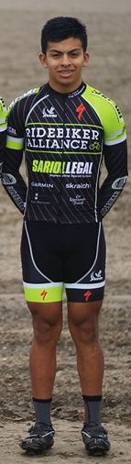

MATTHEW PARK
I was born in South Korea and spent half my life in there and half in South California. I love to ride/race my bike and hang out with the cycling community. My best cycling accomplishments are losing 40+lbs and becoming fit, getting 1st at Brentwood Grand Prix, and becoming an ambassador for Forze Socks. My goals for Europe are to have fun and learn everything I can from racing to the European culture itself. In the Sint-Martinusprijs race, as the first Korean to race in it (I assume), to do well and help the team out the best I can.
.